ICTNWK541 Assessment Tasks

- Explain how internet protocol version 6 (IPv6) works and a brief outline of what you need to do to configure it.
While IPv4 uses 32-bit addresses, IPv6 uses 128-bit addresses, solving some urgent issues:
- IP address shortage
- No need to use DHCP
- No need to use NAT
- Faster routing

Every interface with IPV6 can use its own public IP. Also, IPV6 uses by default IPsec.

To use IPV6 you must:
- Each interface and device must support IPV6
- Enable IPV6 on each interface
- Enable IPV6 addressing
_ Assign an IPV6 address

2. Outline the purpose of Access Control Lists (ACLs).
Access control lists (ACLs)

These are traffic rules (allow, deny) used in routers and switches to allow traffic. Their purpose is to filter traffic based on its source and destination IP address.

There are 2 base types:
1. Standard: filters traffic based on source and destination IP
2. Extended: filters traffic based on IP, port, protocol and message information

There are 4 types:

1. Standard:
2. Extended:
3. Dynamic:
4. Reflexive:

3. Explain how router command line interfaces (CLI) are configured.

command line interface (router CLI):
It is an interface that configures the device through the command line. Switches and routers have this utility.

To configure a device through CLI, you can do so through:
- Console (physical device that connects to the network device)
- SSH
- Telnet

4. Explain the purpose of router debug commands.
Router debug commands:

These are commands used to monitor events in real-time, these events are analysed to identify issues.

Debug mode is activated and deactivated on request or when the device is restarted by default it is deactivated.

5. Complete the table below listing two WAN installation issues that could arise and a solution for each.
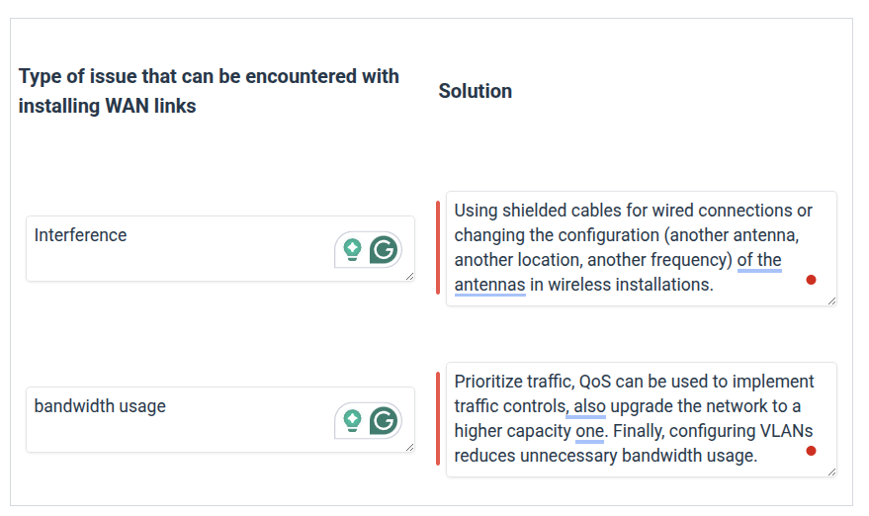

6. Explain why it is important to important to understand strategic objectives and operational activities in relation to installing, configuring and testing WAN links.

It is important to understand the strategic objectives and operational activities because this is what determines the network infrastructure including network security, the regulations and standards to be met.

Based on your strategic objectives, the network is designed to meet growth objectives. For example, scalability, access and cloud use. Regarding operational activities, the appropriate hardware configuration is established. For example, network speed, types of technologies, devices, communication protocols and bandwidth, as well as costs.

Finally, maintenance, documentation and incident resolution processes are also established.

